**User Guide – Understanding Prime Mover (PM) Waiting Time in Yard**

1. **Home Page**
   1. **Introduction**

On this page, there is a short introduction regarding PSA operations, some key definitions, and a short paragraph for the motivation in creating the Shiny app.

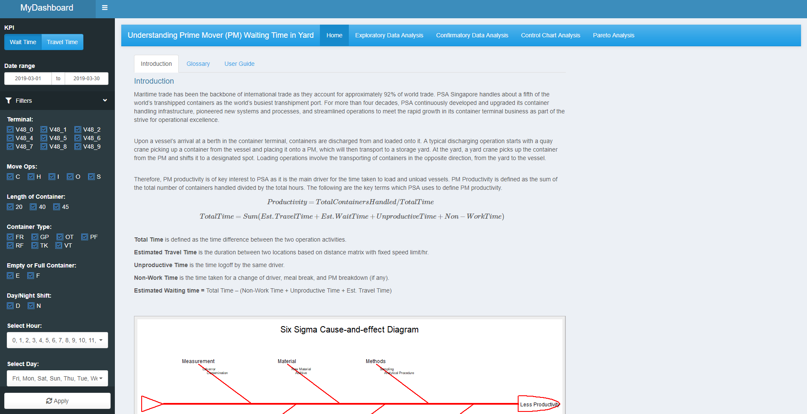

* 1. **Glossary**

A glossary is provided for the definitions and variables used in the data set.

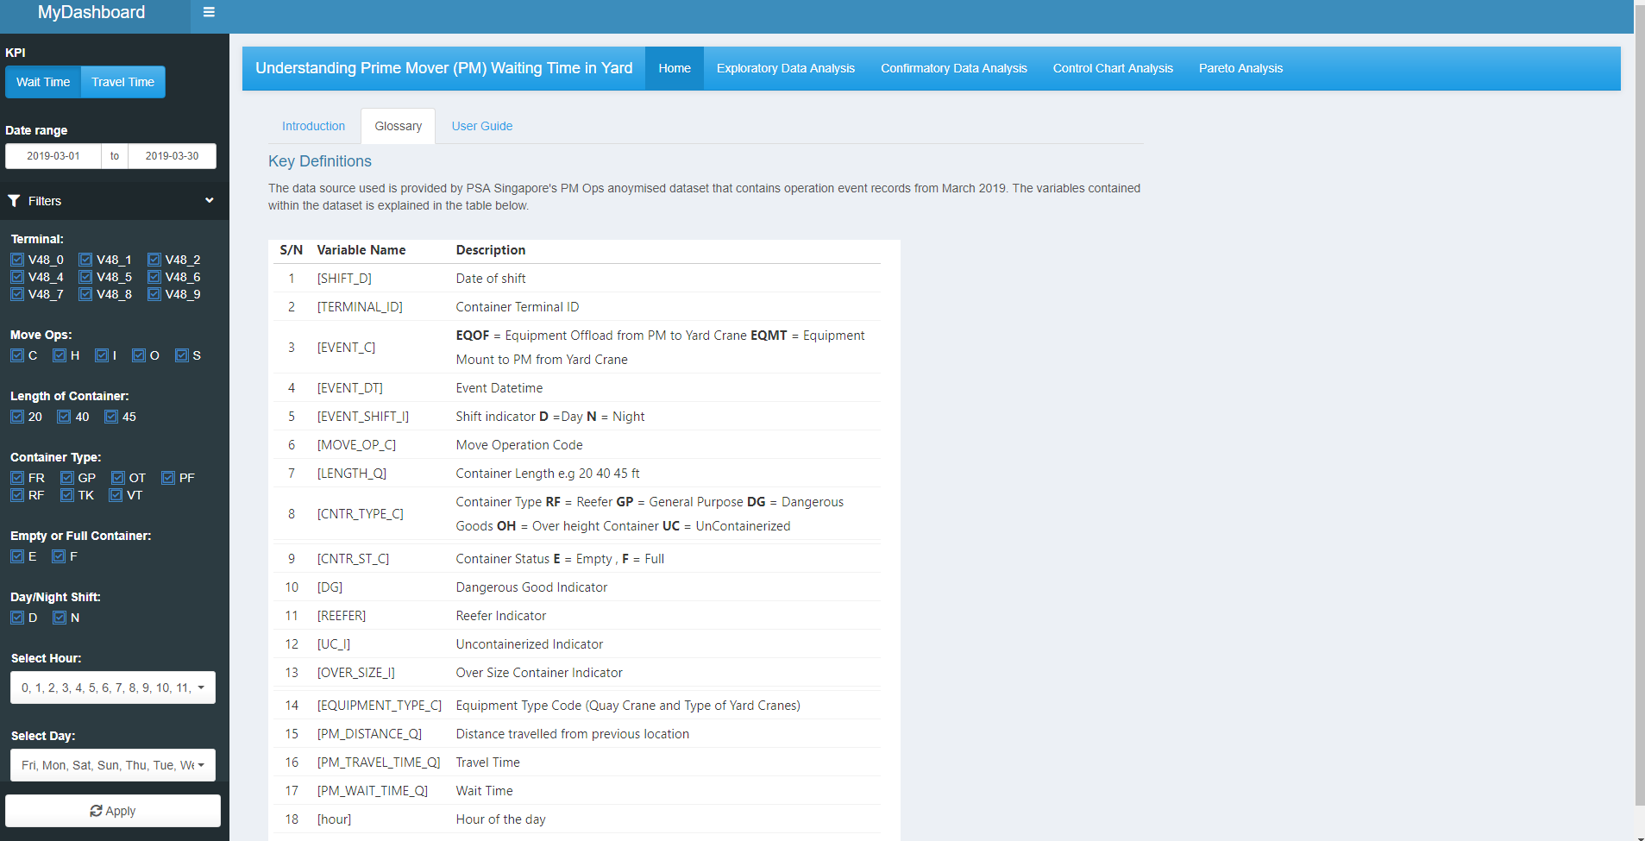

* 1. **User Guide**

A short user guide is provided to explain how to use the application. A more detailed user guide from the project github is linked for a more in-depth explanation on how to use the application.

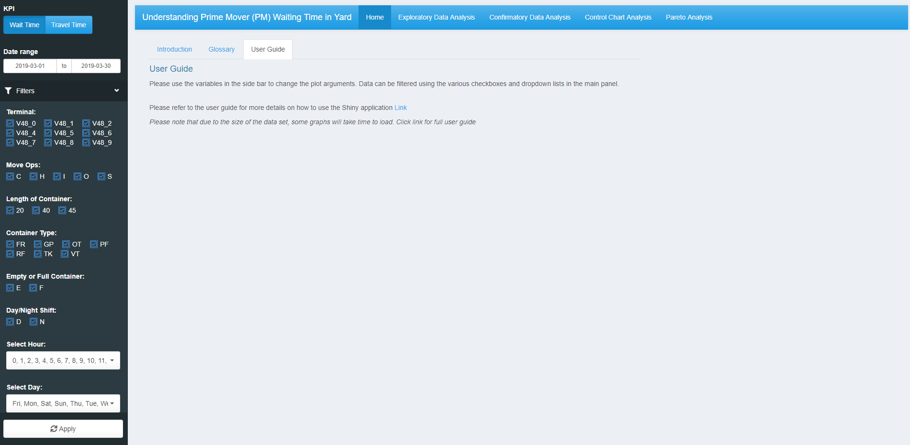

1. **Exploratory Data Analysis**

The first content tab is for exploratory data analysis, helping the user to visualise and understand the various activities in PM operations.

* 1. **Treemap**

A treemap is used to help visualise the hierarchical relationships within PM operations.

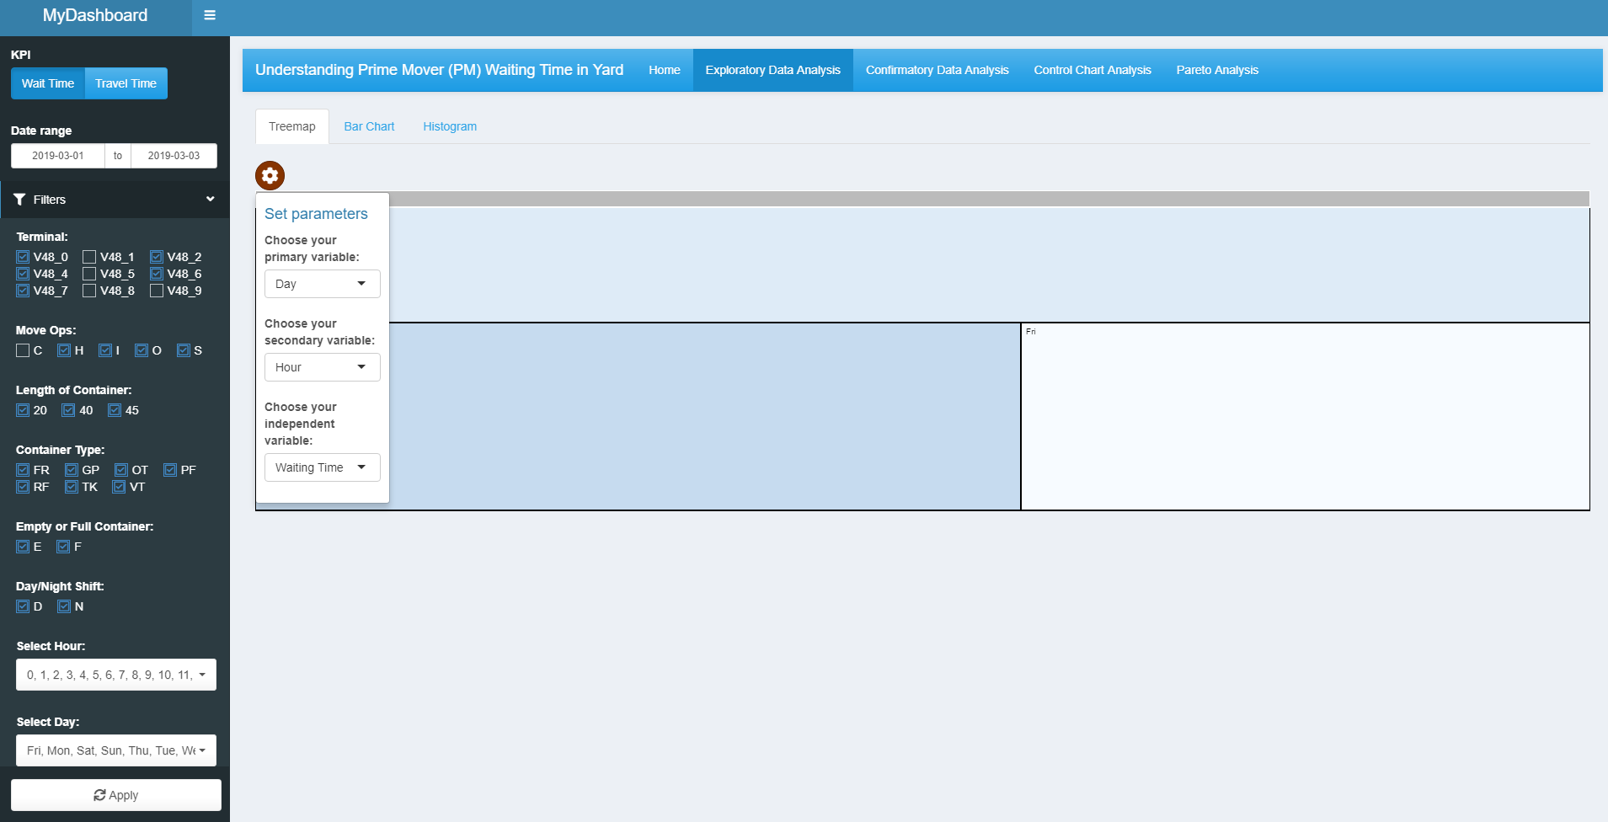

**7**

**6**

**5**

**4**

**3**

**2**

**1**

[1] The sidebar determines the filters applied for the dataset. The first component is a toggle button for the KPIs of waiting time and travel time. Users can toggle this to switch the focus area for analysis. A date selector is used for users to filter and choose the desired dates for analysis. The next filter panel shows all the filters available for the dataset. There are both checkboxes and dropdown-lists for the variables used in the dataset. This enables users to filter out only the relevant information that they want to analyse. This applies to all charts.

[2] The “Apply Changes” button will activate the filters and arguments to generate the plots. This is to prevent instantaneous loading when arguments or filters are changed which can affect the performance of the application. Please select the “Apply Changes” button to update any changes made to the filters and parameters. This applies to all charts.

[3] Click on the gear icon to open the parameters list for the plots. This applies to all charts.

[4] Select the desired primary variable. Only Shift and Day are included. This will form the breakdown of the boxes in the treemap. The continuous variable used is the count of rows in the dataset.

[5] Select the secondary variable. Only Day and Hour are included. This will form the breakdown for the lower-level boxes in the treemap. The continuous variable used is the count of rows in the dataset.

[6] Select between PM Waiting Time and Travel Time for the continuous variable.

[7] The treemap will be shown in this area. This treemap is interactive, and users and select individual boxes to see the count of rows within that particular category or sub-category.

* 1. **Bar Chart**

Bar charts are used to see the distribution and breakdown of the variables in the data set.

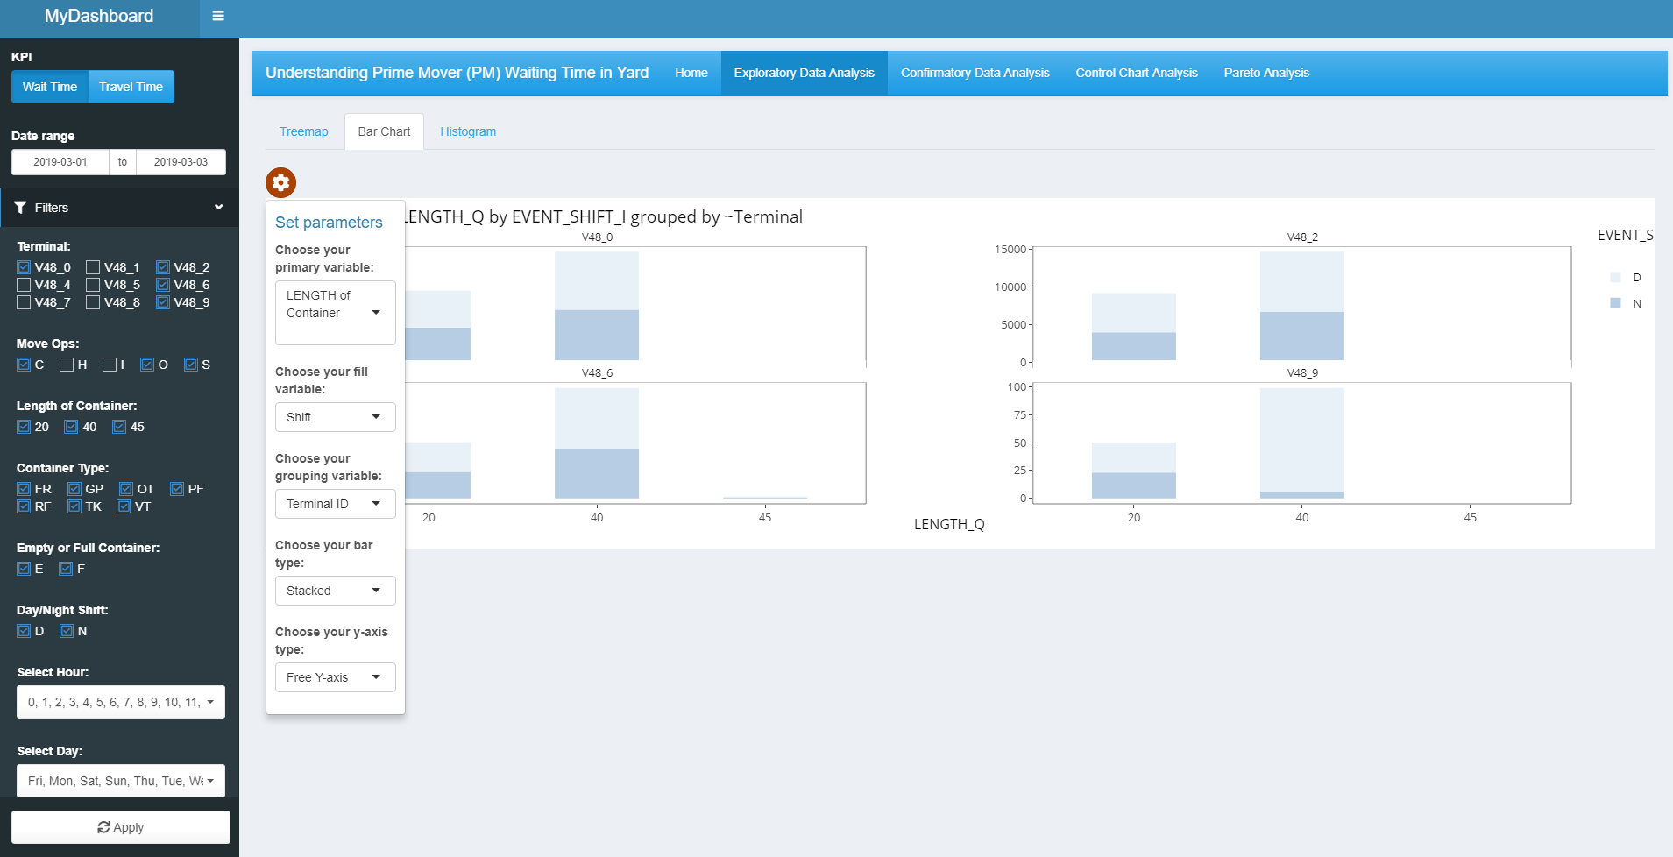

**6**

**4**

**5**

**3**

**2**

**1**

[1] Select the primary variable for the x-axis of the bar chart. The available variables are: Length of container, Shift, Container Type, Empty or Full container, Terminal, Hour, and Day.

[2] Select the fill variable for the bar chart. This will determine the colour fill within the bar chart. The variables available are the same as the primary variable.

[3] Select the grouping variable for the bar chart. This will determine the facet variable which will divide the dataset and plot bar charts according to this variable. The variables available are the same as the primary variable.

[4] Select the stacking type of the bar chart. There are two types available, side-by-side and stacked, which determines the style of the bars in the chart.

[5] Select the type of y-axis. There are two types available, standardised or free-y. This changes the style of the y-axis for facet charts. A standardised axis means that the scale of the y-axes is the same. A free-y-axis refers to each faceted bar chart having its own scale.

[6] The bar chart will be shown in this area. The bar chart is interactive, with users being able to see the counts and details of each bar.

* 1. **Histogram**

Histograms are used to visualise the shape and spread of the continuous variables (waiting time and travel time). Taller bars represent greater counts of data in that range.

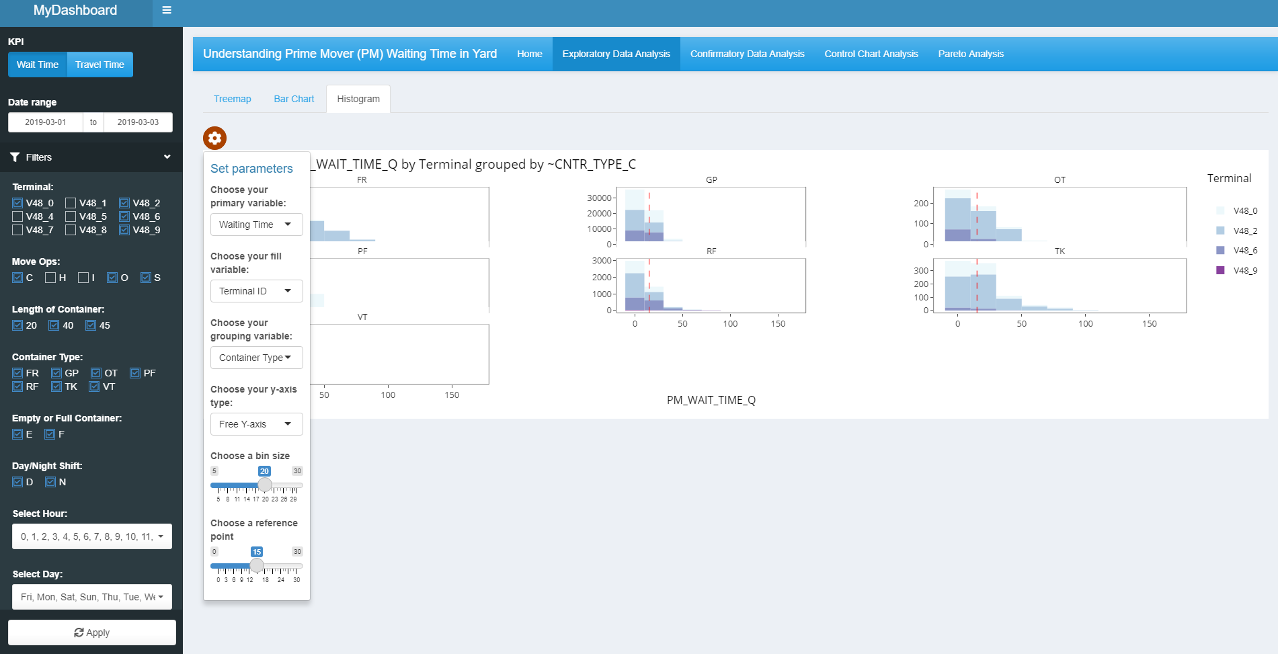

**6**

**5**

**4**

**3**

**2**

**1**

**7**

[1] Select the primary variable for the x-axis. There are two variables, either PM Wait Time or Travel Time.

[2] Select the fill variable for the bar chart. This will determine the colour fill within the bar chart. The available variables are: Length of container, Shift, Container Type, Empty or Full container, Terminal, Hour, and Day.

[3] Select the grouping variable for the histogram. This will determine the facet variable which will divide the dataset and plot histograms according to this variable. The variables available are the same as the fill variable.

[4] Select the type of y-axis. There are two types available, standardised or free-y. This changes the style of the y-axis for facet charts. A standardised axis means that the scale of the y-axes is the same. A free-y-axis refers to each faceted bar chart having its own scale.

[5] Select a bin size using a slider. This will help to determine the range of each bar.

[6] Select a reference point using a slider. This determines the position of the red reference point in the histogram. This can be used to visualise outliers within the histogram.

[7] The histogram will be shown in this area. The histogram is interactive, with users being able to see the counts and details of each chart. If the facet is too detailed, for example with Terminal ID, users can also zoom in using controls on the top right-hand corner of the chart.

1. **Confirmatory Data Analysis**

The second content tab is for confirmatory data analysis, helping the user to visualise and understand the distributions for PM operations.

* 1. **Scatter Plot**

A scatter plot is used to help visualise the correlation between PM Wait Time and Travel Time. This will help the user identify any trends and outliers.

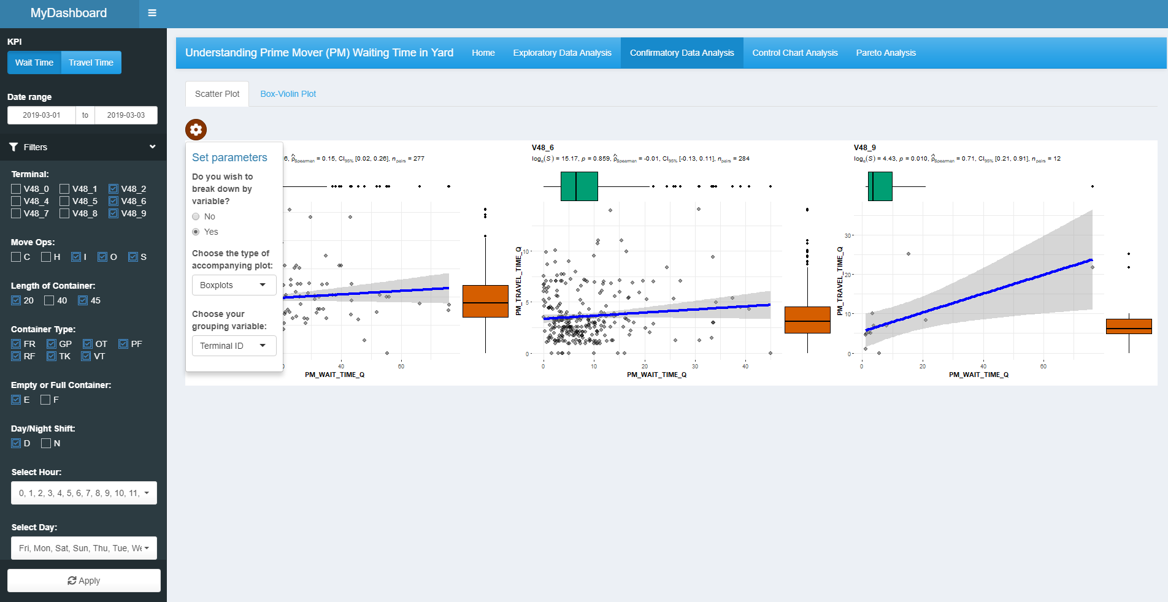

**4**

**3**

**2**

**1**

[1] The radio button selector allows users to decide whether to group or not group by variable. If No is selected, a scatter plot will be generated for the entire data set. If Yes is selected, a conditional panel will appear (Point 3), asking the user for the grouping variable. The scatter plot will then be faceted based on a grouping variable.

[2] Select a type of accompanying plot for the scatter plot. There are two options, histogram and box plot. This determines the type of plots at the sides and tops of the scatter plot. This can help users visualise any distributions better.

[3] Select the grouping variable for the scatter plot. This will determine the facet variable which will divide the dataset and plot according to this variable. The variables available are: Length of container, Terminal, Shift, Container Type, Empty or Full container, Hour, and Day

[4] The scatter plot is plotted here. There is no interactivity in this plot.

* 1. **Box-violin Plot**

The box-violin plots allow users to visualise the means and distributions between different variables. Note: Plot loading times will be long if there is a large dataset due to the calculations required for statistical test.

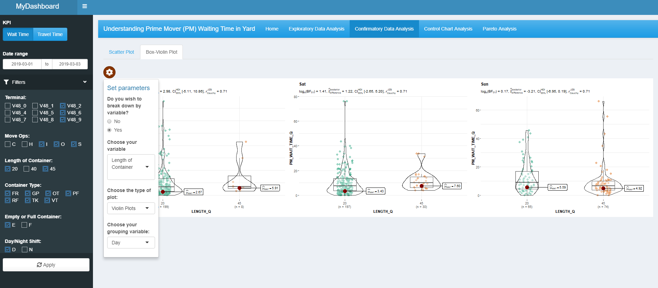

**4**

**3**

**2**

**1**

**5**

[1] The radio button selector allows users to decide whether to group or not group by variable. If No is selected, a box-violin plot will be generated for the entire data set. If Yes is selected, a conditional panel will appear (Point 4), asking the user for the grouping variable. The box-violin plot will then be faceted based on a grouping variable.

[2] Select the primary variable for the x-axis of the box-violin chart. The available variables are: Length of container, Shift, Container Type, Empty or Full container, Terminal, Hour, and Day.

[3] Select a type of plot for the box-violin plot. There are three options, box-violin plot, box plot, and violin plot. This determines the type of plots that will be generated.

[4] Select the grouping variable for the box-violin chart. This will determine the facet variable which will divide the dataset and plot the charts according to this variable. The variables available are the same as the primary variable.

[5] The plot is created here. There is no interactivity with the plot. The Kruskal-Wallis Test is used for the plots to determine if there are differences in the mean.

1. **Pareto Analysis**

A pareto chart is used to visualise the cumulative performance for each of the relevant categories to see which category contributes the most to the productivity of PM operations.

* 1. **Overview**

The overview allows users to visualise the impact of various types of time spent on the productivity of PM operations.

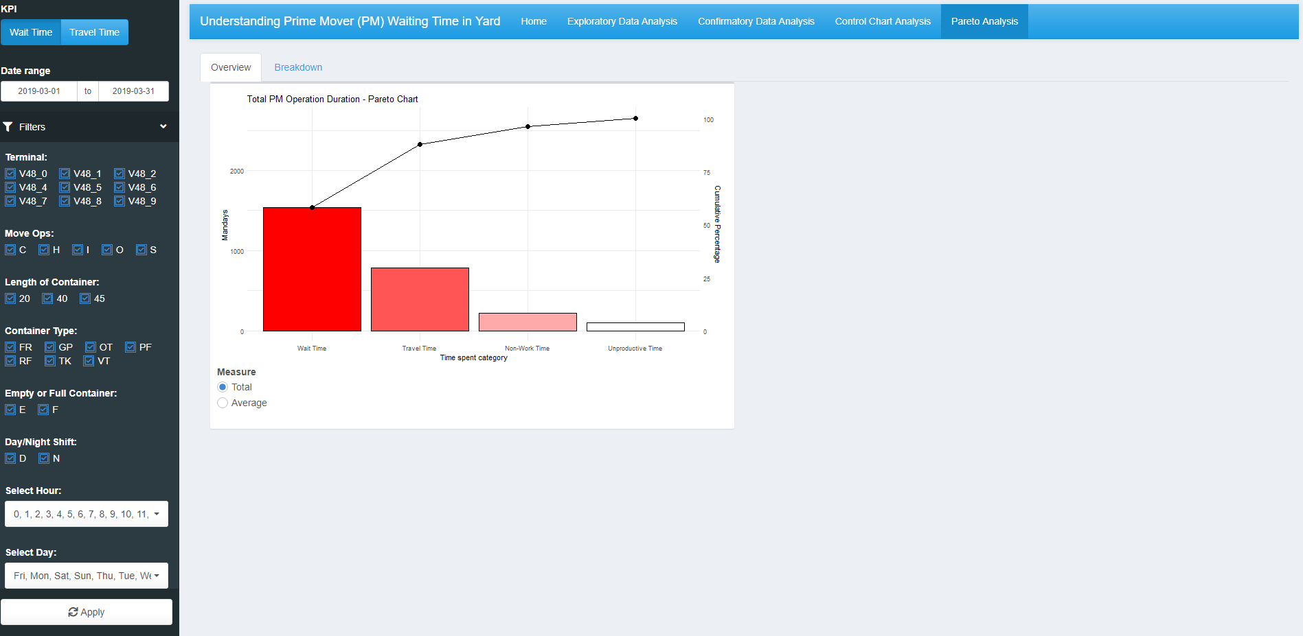

**1**

[1] This plot is only affected by the filters in the side bar. There is no interactivity feature available.

* 1. **Breakdown by Facet**

The facet view for the pareto charts showcases the different pareto charts faceted by different variables.

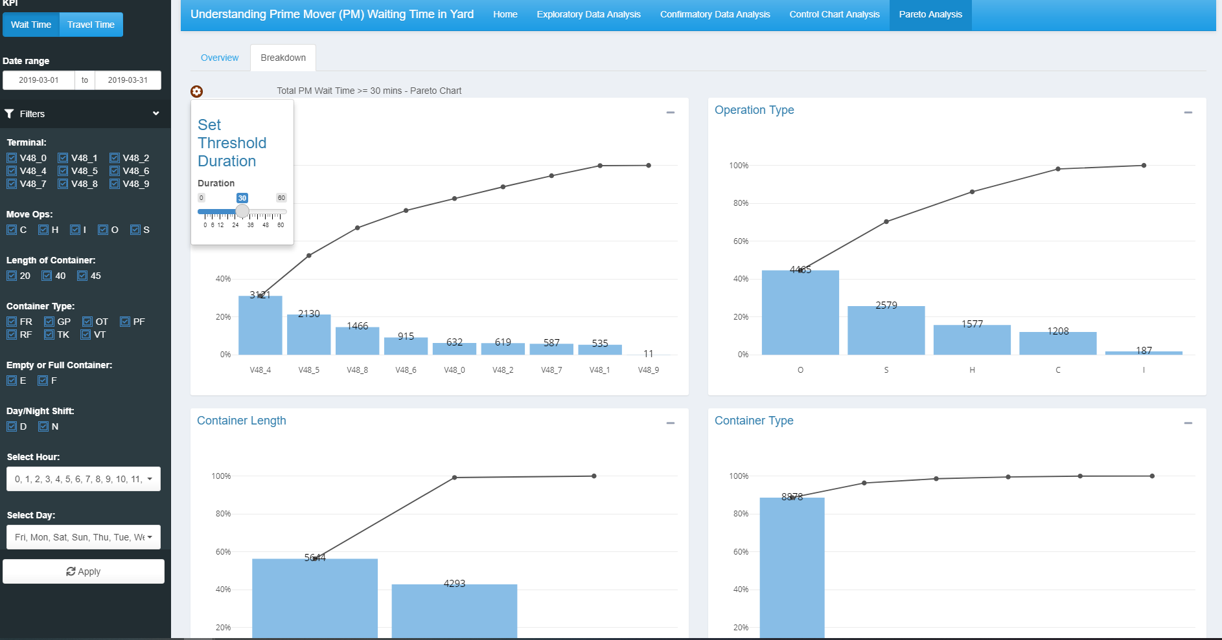

**2**

**1**

[1] Select the threshold duration for the pareto chart. This filters out the data to show the number of activities that are above the set threshold.

[2] These charts are the pareto charts faceted by variables. The charts are interactive and have tooltips that will appear when hovered over, with various information like count of activities and cumulative percentage.

1. **Control Chart**

The control chart enables users visualise the mean, upper limit, and lower limit for PM operations over time. By comparing current data to control lines, users can visualise whether operations are within expected limits or if there are anomalies that need to be investigated.

Note: Plots will not show correctly if date range is less than 7 days as there is insufficient information for the time series.

* 1. **Mean (xbar) & Standard Deviations (s)**

The basic plots show both the mean and standard deviations.

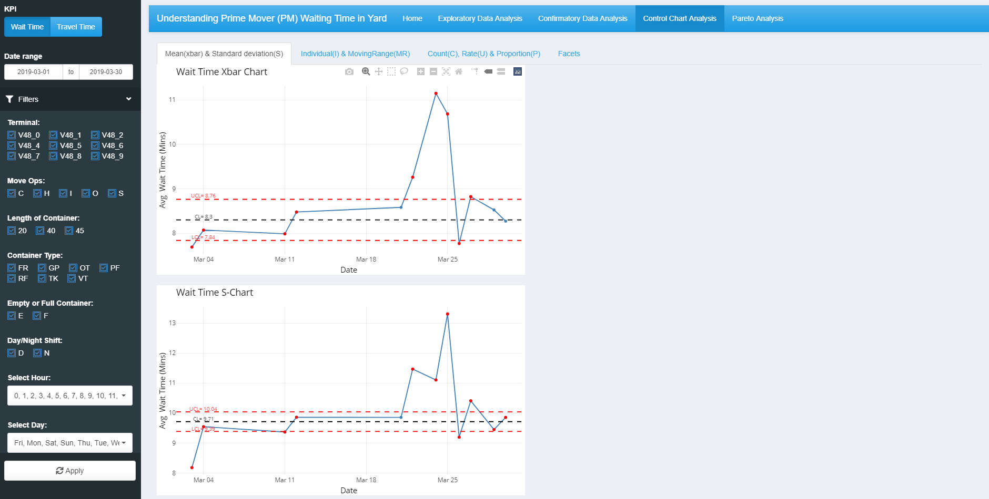

**2**

**1**

[1] The first chart shows the mean, upper and lower limits for the mean waiting / travel time. This chart is interactive, and users can hover over the plotted points to view tooltips.

[2] The first chart shows the mean, upper and lower limits for the standard deviation for waiting / travel time. This chart is interactive, and users can hover over the plotted points to view tooltips.

* 1. **Individual (I) & Moving Range (MR)**

The individual & moving range control charts are to visualise the most recent N number of records in the dataset.

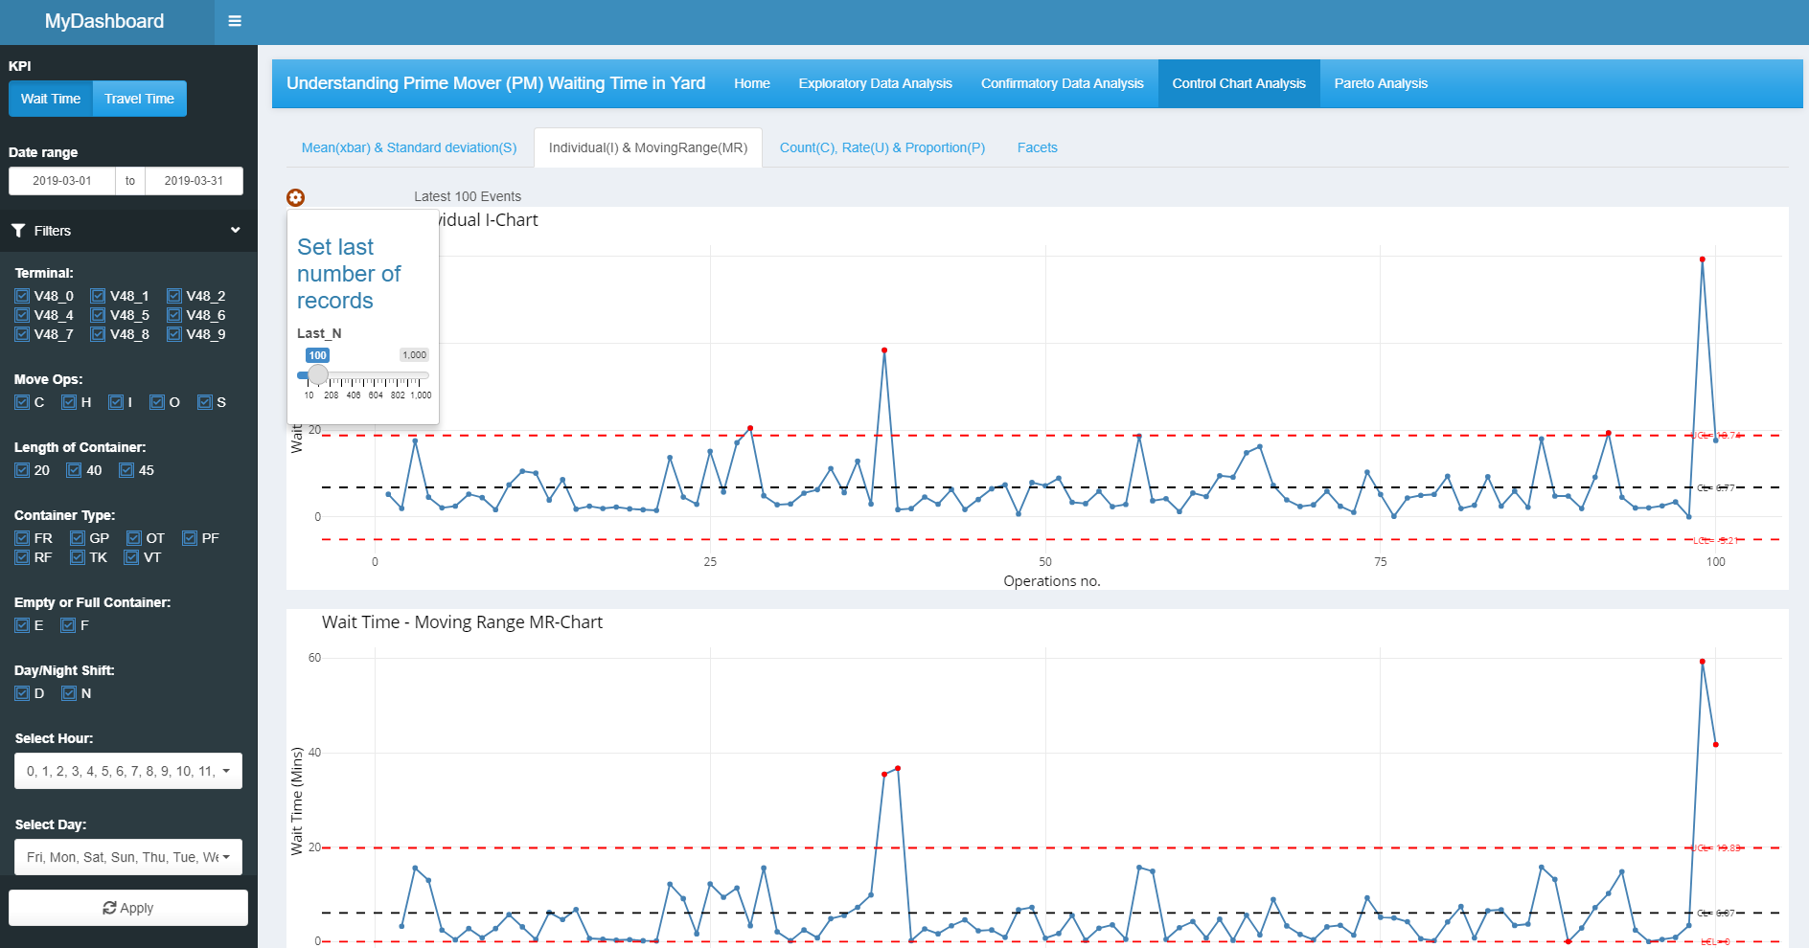

**3**

**1**

**2**

[1] Select the most recent N number of views for the plot

[2] The first chart shows the mean, upper and lower limits for the Individual I-chart. This chart is interactive, and users can hover over the plotted points to view tooltips.

[3] The first chart shows the mean, upper and lower limits for the Moving Range MR chart. This chart is interactive, and users can hover over the plotted points to view tooltips.

* 1. **Count (C), Rate (U), & Proportion (P)**

The Count, Rate and Proportion control charts enables users to track if there are variations in volumes being handled by PM operations.

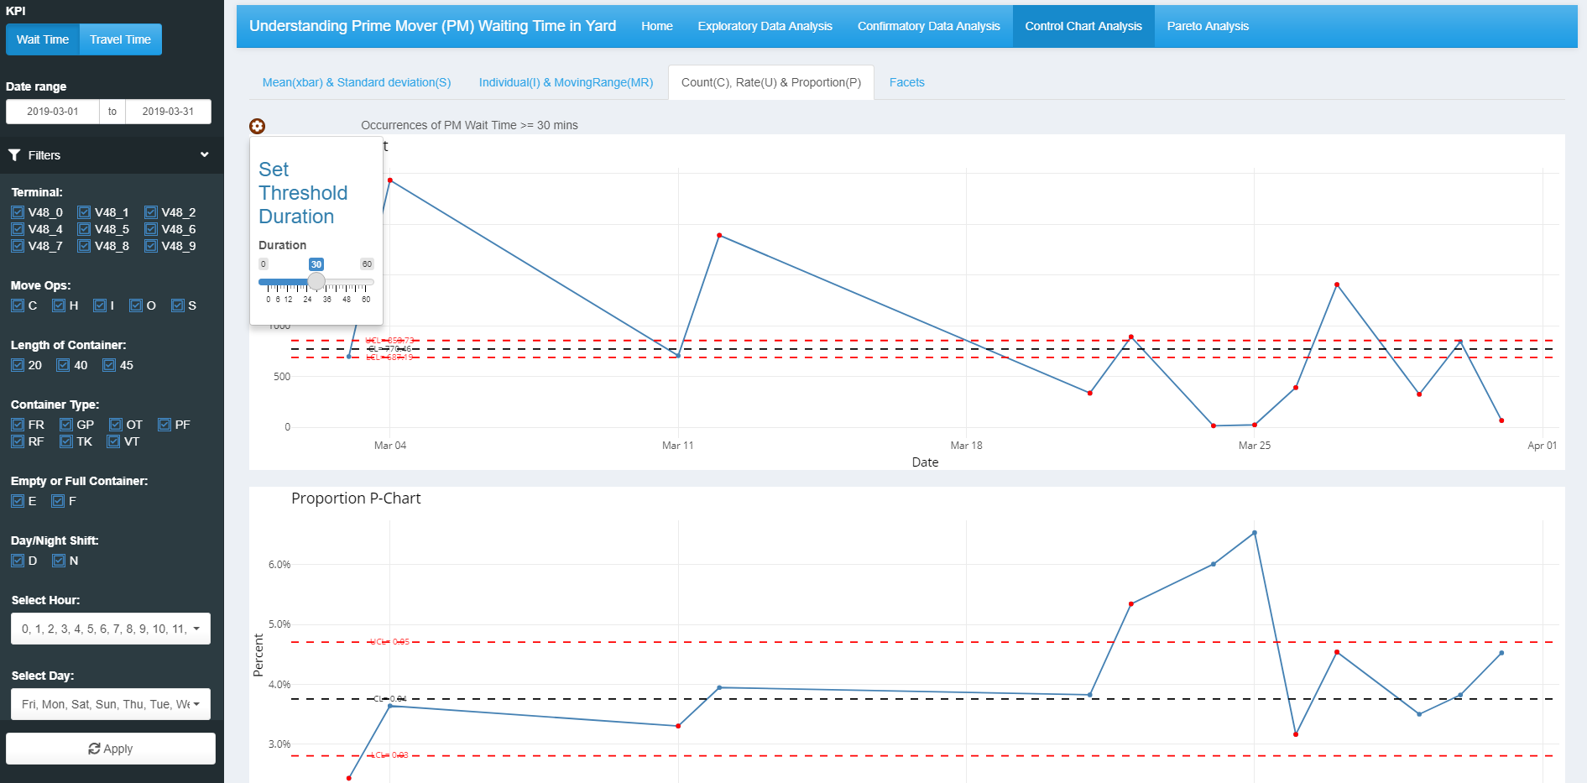

**4**

**3**

**2**

**1**

[1] Select the threshold duration for the pareto chart. This filters out the data to show the number of activities that are above the set threshold.

[2] The first chart shows the mean, upper and lower limits of the number of activities. This chart is interactive, and users can hover over the plotted points to view tooltips.

[3] The second chart shows the mean, upper and lower limits of the proportion of number of activities. This chart is interactive, and users can hover over the plotted points to view tooltips.

[4] The third chart shows the mean, upper and lower limits of the rate of activities. This chart is interactive, and users can hover over the plotted points to view tooltips.

* 1. **Facets**

The facet panel showcases the mean and standard deviation control charts that have been faceted by a variable

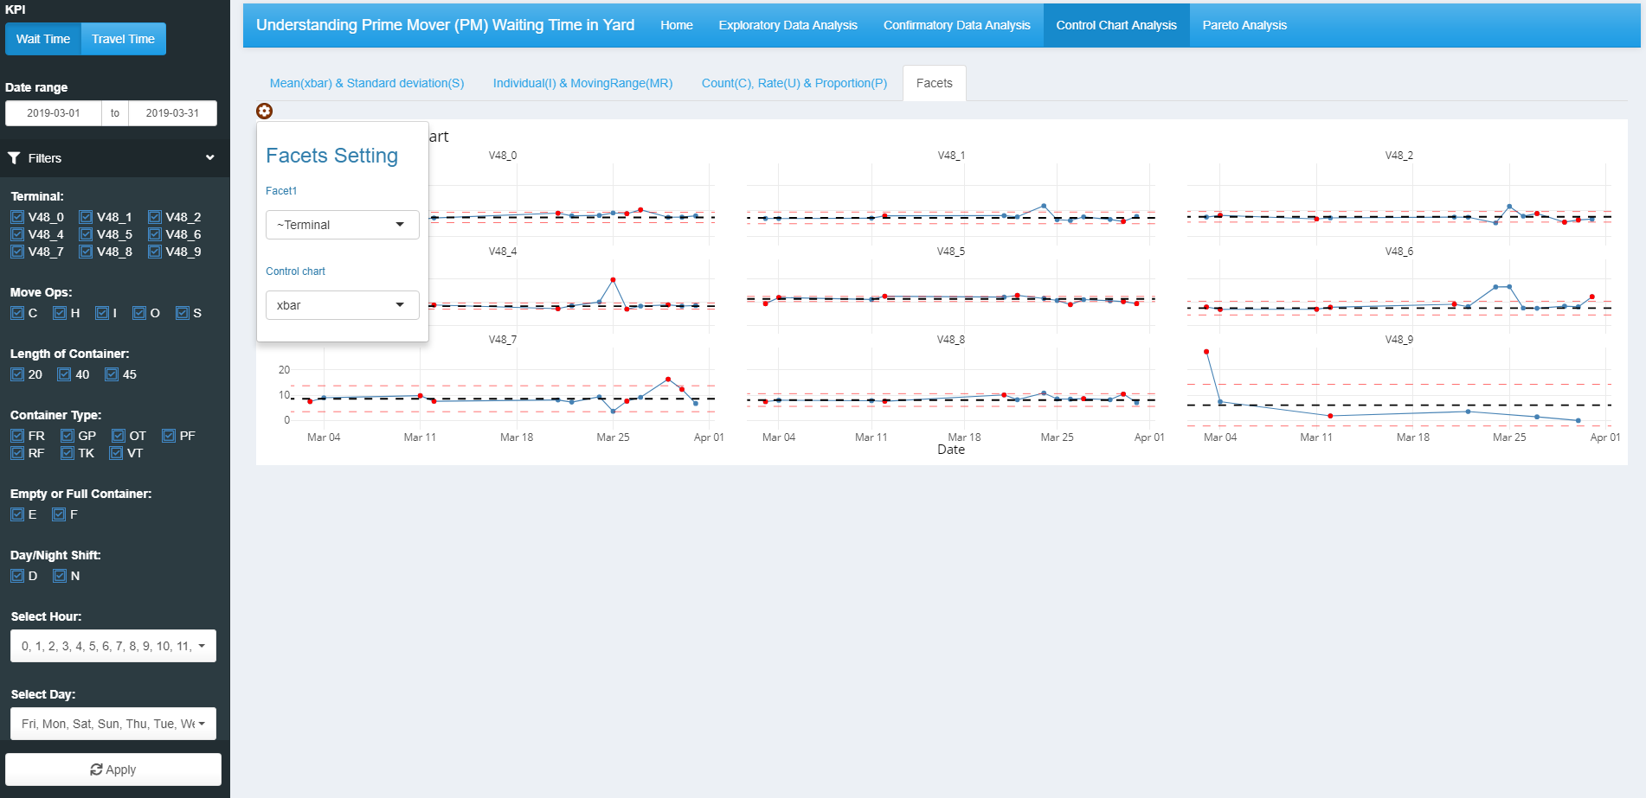

**3**

**2**

**1**

[1] Select the desired grouping variable. The available variables are: Length of container, Shift, Container Type, Empty or Full container, Equipment Type, Terminal, and Movement Type

[2] Select the desired control chart. The options are the x-bar chart and the s.d. chart.

[3] The control charts are plotted here, faceted by the grouping variable. This chart is interactive, with users being able to zoom in to the desired scale of the chart. Users can also hover over plotted points to view tooltips.